**Git– Question & Answers**

**Git Fundamentals:**Question 1:What is the purpose of the git ‘init’ command, and when should it be used?

The ‘git init’ command is used to create a new, empty Git repository in a directory. It initializes the directory as a Git repository by creating a hidden ‘.git’ folder, which stores all the metadata and version control information for the project.

**Purpose of the git init Command**

The git init command is used to create a new, empty Git repository in a directory. It initializes the directory as a Git repository by creating a hidden .git folder, which stores all the metadata and version control information for the project.

**Key Functions of git init**

1. **Initialize a Repository:**
   * Creates a new Git repository in the current directory or a specified directory.
   * Establishes the foundation for tracking changes in the project files.
2. **Reinitialize an Existing Repository:**
   * Can be used to reinitialize an existing repository if the .git folder is accidentally deleted or corrupted.
3. **Set Up Bare Repositories:**
   * Can initialize a "bare" repository, which is used as a central repository for collaboration, without a working directory.
   * Example: git init --bare.

**When Should git init Be Used?**

1. **Starting a New Project:**
   * When beginning a new project and you want to use Git for version control.

Example:  
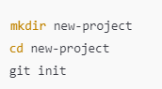

2. **Turning an Existing Project into a Repository:**

* If you already have a directory with project files and want to start tracking them with Git.

Example:  
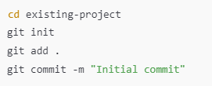

Question 2:What is the difference between ‘git add.’ and ‘git add -A’?  
Provide an example of when you would use each.

Both commands stage changes to the Git index (staging area) but differ in **scope** and **behavior** regarding tracked and untracked files.

**1. git add .**

* **Scope:**
  + Adds all **new** and **modified** files in the current directory and its subdirectories to the staging area.
  + Does **not** stage deleted files outside the current directory unless explicitly mentioned.
* **Behavior:**
  + Operates **relative to the current directory** where the command is executed.
  + Ignores deleted files that are not in the current directory.
* **Use Case:**
  + When you want to stage only the files that have been added or modified within a specific directory without affecting deletions outside it.

**2. git add -A**

* **Scope:**
  + Stages **all changes** in the repository, including:
    - New files
    - Modified files
    - Deleted files
* **Behavior:**
  + Operates **globally across the entire repository**, regardless of the current directory.
  + Ensures that all tracked and untracked files, as well as deletions, are staged.
* **Use Case:**
  + When you want to stage every change across the entire repository, including deletions, for a comprehensive commit.

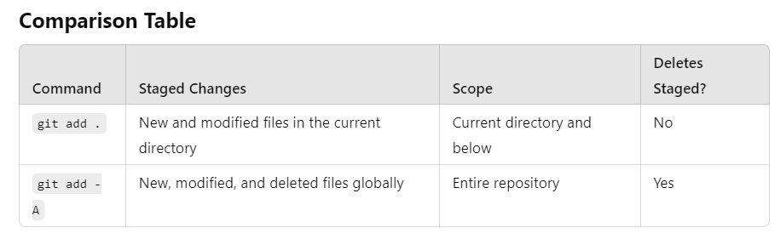

**When to Use Each Command**

**git add .**

* **Scenario:**
  + You are working in a specific directory and want to stage only the changes within that directory.
* **Example Use Case:**
  + You're updating multiple files in a subproject but don't want to accidentally stage unrelated deletions or changes elsewhere.

**git add -A**

* **Scenario:**
  + You want to stage all changes in the repository, including new files, modifications, and deletions, regardless of the current directory.
* **Example Use Case:**
  + Before making a commit for a global update or cleanup operation, ensuring all changes are included.

**Practical Tip**

* If unsure, use git status to review changes before staging. This helps you decide whether to use git add . or git add -A based on the scope of changes you want to include in your commit.

Question 3:How do you commit changes with a meaningful commit message using Git?  
Provide an example.

**Committing Changes with a Meaningful Commit Message in Git**

Committing changes in Git involves capturing the current state of your project in a snapshot. A meaningful commit message helps explain what was changed and why, making the repository history easier to understand for collaborators (and your future self!).

1**. Stage Changes:**

* Add files to the staging area using git add or git add -A.

2. **Commit Changes with a Message:**

* Use the git commit -m "Your meaningful commit message" command.



3. **Write Descriptive Commit Messages:**

* A good commit message should:
  + Be concise but informative.
  + Use imperative mood (e.g., "Fix bug" instead of "Fixed bug").
  + Describe **what** and **why**, not just **how**.

**Example of a Meaningful Commit Message**

**Good Example:**



What: Fixes how login errors are handled.

Why: To ensure users see clear and friendly error messages.

**Poor Example:  
**

**Git Branching and Merging:**  
Question 1:What is the purpose of creating a new branch in Git, and how do you create one?

In Git, a branch is a pointer to a specific commit in the repository. Branching allows you to work on a separate line of development without affecting the main codebase. It is especially useful for:

1. Isolating Changes:
   * You can develop new features, fix bugs, or experiment with changes without interfering with the main branch (usually main or master).
2. Collaborative Development:
   * Each developer can work on their branch independently, and changes can be merged into the main branch after review.
3. Safe Code Management:
   * Reduces the risk of breaking the main branch while testing or developing new ideas.
4. Organizing Workflow:
   * Helps maintain a clean and logical commit history by keeping unrelated changes in separate branches.

**How to Create a New Branch in Git**

**1. Create a New Branch**

**Example:**



**2. Create and Switch to a New Branch**

Use the git checkout command (older versions) or the more modern git switch:



Example:



OR (modern Git):



- This creates the branch and checks it out in one step.

**3. Verify the Current Branch**

To see which branch you're working on:



Output:

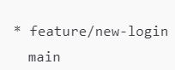

The * indicates the current branch.

**4. Push the Branch to the Remote Repository (Optional)**

If you want others to collaborate on the branch, push it to the remote repository:

Example:



Question 2:How do you switch between branches using Git?

To switch between branches in Git, use:

1. **Modern Command:** 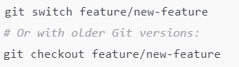



2. **Older Command:**

Example:

Verify Current Branch:



The active branch is marked with *.

**Notes:**

* Ensure all changes are committed or stashed before switching to avoid conflicts.

Question 3:What is a merge conflict, and how do you resolve it in Git?

A **merge conflict** occurs when Git cannot automatically reconcile differences between two branches during a merge. This happens if:

1. The same file is modified in both branches.
2. Changes overlap or contradict each other.

**Steps to Resolve a Merge Conflict**

1. **Attempt the Merge:**



2. **Identify Conflicted Files:** Git will list files with conflicts:  
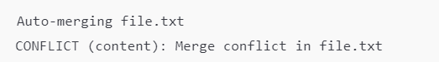  
  
3. Edit the Conflicted File(s):  
- Conflicted sections are marked like this:

- Manually choose or combine changes.

4. Mark Conflicts as Resolved:

5. Complete the Merge:  


**Git Remote Repositories:**  
Question 1:What is the difference between ‘git push’ and ‘git pull’?  
Provide an example of when you would use each.  
  
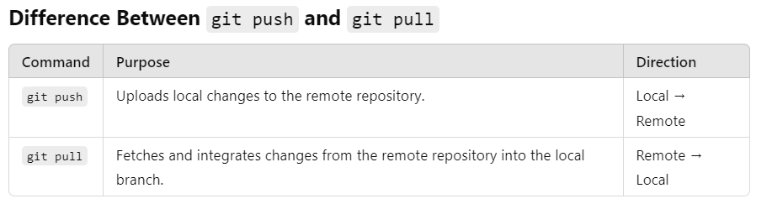

**When to Use Each**

**git push**

* **Use Case:** After committing changes locally, you want to share them with the remote repository for collaboration.
* Example:  
  
* This pushes changes from the local main branch to the remote main branch.

**git pull**

* **Use Case:** Before starting work, you want to ensure your local branch is up-to-date with the latest changes from the remote repository.
* Example:  
  
* This pulls changes from the remote main branch into your local main branch.

**Key Tip:**

* Always pull (git pull) before pushing (git push) to avoid conflicts, especially in collaborative environments.

Question 2:How do you link a local Git repository to a remote repository on GitHub or another platform?  
  
To link a local Git repository to a remote repository, follow these steps:

**Steps to Link a Local Git Repository to a Remote**

1. **Initialize the Local Repository (if not already done):**
2. **Add the Remote Repository:** Use the git remote add command:  
    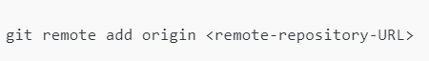
3. Verify the Remote Link:  
   A close-up of a logo

   Description automatically generated

Output:

4. Push Changes to the Remote Repository:  


**Notes:**

* Replace <branch-name> with your branch, e.g., main.
* Ensure you have permission to push to the remote repository. Use SSH for authentication if preferred.

Question 3:What is the purpose of ‘git fetch’, and how does it differ from ‘git pull’?  
**Purpose of git fetch**

git fetch downloads the latest changes from the remote repository but does not integrate them into your local branch. It updates the remote tracking branches (e.g., origin/main) without altering your working directory.

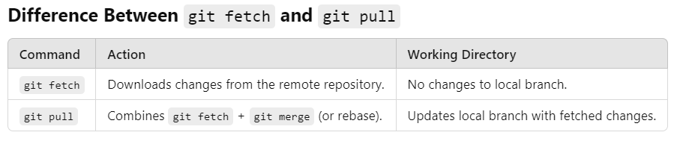  
  
**When to Use Each**

**git fetch**

* **Use Case:** When you want to review remote changes before merging them into your branch.
* **Example:**A black and yellow text

  Description automatically generated
* This fetches changes and lets you inspect them with git log.

**git pull**

* **Use Case:** When you want to fetch and immediately integrate remote changes into your current branch.
* **Example:**
* This fetches and merges changes from origin/main into your current branch.

**Key Tip:**  
Use git fetch if you want more control over merging, and git pull for a quick update.

**Git Workflow and Best Practices:**  
Question 1:Describe a typical Git workflow for a collaborative project. How do you handle changes from multiple contributors?

**Typical Git Workflow for a Collaborative Project**

1. **Clone the Repository:** Each contributor clones the remote repository:  
   
2. **Create a New Branch for Your Work:** Use branches to isolate changes for features or fixes:  
   
3. **Make Changes and Commit:**  
   - Edit files.  
   - Stage changes:  
     
     
   - Commit with a meaningful message:  
   
4. **Sync with the Remote Repository:** Always pull the latest changes before pushing:  
   
5. Push Your Branch to the Remote Repository:  
   
6. Create a Pull Request (PR):

On the platform (e.g., GitHub), create a PR to merge your branch into the main branch.

Add a description and reviewers.

**Handling Changes from Multiple Contributors**

1. **Communication and Clear Roles:**
   * Use a project management tool to assign tasks and avoid overlapping changes.
2. **Keep Branches Updated:**
   * Regularly pull changes from the main branch:  
     
   * Rebase or merge updates into your branch to stay current.

3**. Resolve Merge Conflicts:**

* Conflicts arise when two contributors edit the same file.
* Edit the conflicted files, stage them, and commit:  
  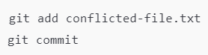

4**. Code Reviews:**

* Ensure all PRs are reviewed by peers to maintain code quality.

**Best Practices**

* Use descriptive branch names (e.g., feature/add-login, bugfix/fix-typo).
* Write clear commit messages.
* Avoid pushing directly to the main branch.
* Synchronize frequently to avoid large, conflicting changes.

Question 2:What is the importance of writing meaningful commit messages, and how do you ensure your messages are descriptive?

**Importance of Meaningful Commit Messages**

1. **Clarity:** Helps others (and your future self) understand what was changed and why.
2. **Traceability:** Makes it easy to track when and why changes were made.
3. **Collaboration:** Improves communication among team members in a collaborative project.
4. **Debugging:** Simplifies finding the cause of issues by providing context for changes.
5. **Documentation:** Acts as a living record of the project’s history.

**How to Write Descriptive Commit Messages**

1. **Use the Imperative Mood:**
   * Write as if you're giving a command (e.g., "Fix bug" instead of "Fixed bug").  
     

**2. Be Concise Yet Informative:**

Include what was changed and why in 50 characters or less in the summary line.



3. **Provide Details When Necessary:**

* Use a blank line after the summary, followed by additional explanation if needed.

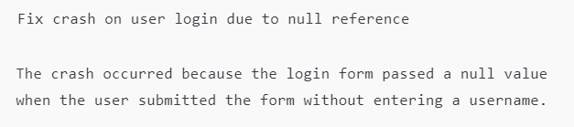

**4. Focus on Single Changes per Commit:**

* Each commit should address one issue or feature.

**Best Practices**

* Start with a concise summary.
* Explain **why** the change was made if it’s not obvious.
* Follow a consistent format to maintain readability across the team.

Question 3:How do you use Git to track changes and identify bugs or errors in your code?

**Using Git to Track Changes and Identify Bugs**

1. **Track Changes:**
   * **View Commit History:** Use git log to see a history of commits, including messages, authors, and timestamps:  
     
   * **Inspect Specific Changes:** Use git show to view details of a specific commit:  
     
   * Example:  
     
   * **Compare Changes Between Commits:** Use git diff to compare differences between commits, branches, or the working directory.  
     
   * Example:  
     
2. Identify Bugs:  
   **- Blame to Identify Authors:** Use git blame to find who made specific changes to a file and when.  
     
     
   - Example:  
     
     
     
     
   - **Find When a Bug Was Introduced:** Use git bisect to perform a binary search through commits to locate the specific commit that introduced a bug:  
   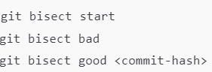
3. Debugging Workflow:  
   - **Revert to a Previous Commit:** Temporarily check out a previous state to test or debug:  
   A close up of a text

   Description automatically generated  
     
   - To return to the latest state:  
   A close-up of a word

   Description automatically generated  
     
   - **Revert Changes Without Undoing History:** Use git revert to create a new commit that undoes changes from a specific commit:



**Best Practices for Debugging with Git**

* Write clear and descriptive commit messages to make history easier to understand.
* Commit frequently with small, isolated changes to simplify identifying where a bug was introduced.
* Use branching to experiment or fix bugs without affecting the main codebase.

**Git Troubleshooting:**  
Question 1:How do you recover from mistaken commit or push to a remote repository?

**Recovering from a Mistaken Commit or Push**

Scenario 1: Mistaken Commit (Local Only)

1. **Undo the Last Commit (Without Losing Changes):** Use git reset to - - unstage changes and keep them in your working directory:  
     
     
   - HEAD~1: Refers to the last commit.  
     
   - Use --hard instead of --soft if you want to discard the changes completely.
2. **Amend the Last Commit:** If you need to fix a mistake in the last commit, you can amend it:  
     
   - This updates the last commit with new changes or a revised message.

**Scenario 2: Mistaken Push to Remote Repository**

1. **Undo the Commit Locally First:** Reset your branch to the previous state:  
   
2. **Force Update the Remote Branch:** Push the corrected state using --force:  
     
     
   - **Warning:** Use --force carefully; it overwrites the remote history and may affect others.

**Scenario 3: Mistaken Push to the Wrong Branch**

1. **Reset the Wrong Branch:**
   * Switch to the incorrect branch:  
     
   * Reset it to its previous state:  
     
2. Push Changes to the Correct Branch:  
   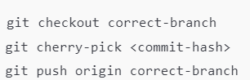

**Tips to Prevent Issues:**

* Use branches for every feature or bug fix to isolate changes.
* Review changes before committing with git diff.
* Avoid --force unless absolutely necessary; consider --force-with-lease for safer overwrites.  
  

Question 2:What is the purpose of ‘git reset’ and how do you use it to undo changes?

**Purpose of git reset**

git reset is used to undo changes by modifying the **staging area**, **commit history**, and/or **working directory**. It can be used to unstage files, undo commits, or reset your repository to a previous state.

**Types of git reset**

1. **--soft**
   * Keeps changes in the staging area.
   * Removes the specified commit(s) from the history.
   * **Use Case:** Adjust the commit history without losing changes.  
     
   * This undoes the last commit and keeps the changes staged.
2. **--mixed** (Default)

* Keeps changes in the working directory but unstages them.
* Removes the specified commit(s) from the history.
* **Use Case:** Correct staged changes without losing work.  
  

1. **–-hard**  
   - Deletes changes from the working directory and history.

- Use Case: Discard all changes permanently.  


**How to Use git reset to Undo Changes**

**1. Undo a Commit:**

* Soft reset:  
  
* Mixed reset:  
  A black text on a white background

  Description automatically generated
* Hard reset:  
  

**2. Unstage Changes:**

If you accidentally staged files, unstage them:  
  
  
Example:  


**3. Reset to a Specific Commit:**Move the branch pointer to an earlier commit:

  
  
  
**Key Considerations**

* **--hard** is irreversible; use it cautiously.
* Use git log to identify the commit hash for resets.
* To undo git reset, use git reflog to locate the commit and restore it:  
  